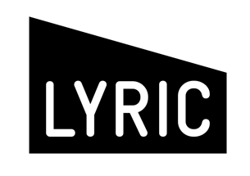


BASIC INFORMATION
Company/artist name:
Show title:
Primary contact email:
Primary contact phone:

⬝ Information about the artist/company and your show (max. 500 words)

⬝ Is the show available to perform for the full festival (5th August – 31st August 2026)

⬝ Who the target audience is and why (max 200 words)

⬝ Why are you interested in performing at the Edinburgh Fringe (max. 200 words)

- How will you get the show Fringe-ready? Please give an overview of the key elements of your budget, timeline for logistics and your production team (max. 500 words)

⬝ Why is this opportunity important for your and your development (max. 200 words)

⬝ Please provide links to supplementary material in support of your application (this could include videos/trailers of previous work, R&D footage, scripts/excerpts, images, etc.)

Please also send a copy of the script for this show, if available.

Signed Company lead:
Date:

Deadline for applications is 12 noon on Wednesday 25th February 2026. If your submission is shortlisted, interviews will take place in the week following on Thursday 5th March 2026. Due to the timeline no alternative dates can be offered.

Please return this form and a writing sample by email to: newwork@lyrictheatre.co.uk

