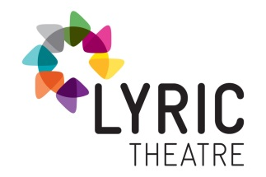

ATTACH PHOTO HERE
APPLICATION FORM FOR SENIOR THEATRE SCHOOL (age 15-18/yr 13-14)

Name …………………………………………………………………………………………………………………………………..
Address …………………………………………………………………………………………………………………………………..
Postcode …………………………………………………………………………………………………………………………………..
School/College …………………………………………………………………………………………………………………………………..
Telephone Home ………………………………………. Mobile (parent’s if under 18) …………..……………………
Email (parent’s if under 18) ………………………………………………………………………………………………………..
Date of Birth ………………………………………………….. Age ………………………………………………………….
Just for Information;
Do you study Drama/Theatre Studies at School or College? Yes No
Are you considering applying to Drama School in the future? Yes No Unsure
Please tell us what Drama experience you have and what you hope to gain from attending weekly Theatre School classes?
……………………………………………………………………………………………………………………………….............................
……………………………………………………………………………………………………………………………….............................
……………………………………………………………………………………………………………………………….............................
……………………………………………………………………………………………………………………………….............................
……………………………………………………………………………………………………………………………….............................
……………………………………………………………………………………………………………………………….............................
IMPORTANT APPLICATION INFORMATION:
Once completed, please return form to: Erin Hoey at erinhoey@lyrictheatre.co.uk by 4pm on Thursday 1st September 4pm.

